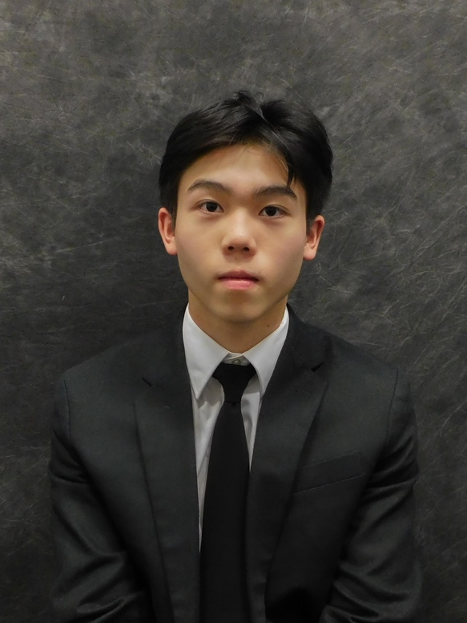

- Name and Hometown: Andrew Choy – Brooklyn, NY

- Major: Nursing

- Extra-Curricular Activities:

- M. Louise Fitzpatrick College of Nursing Ambassador, Panelist
- Special Olympics, Medical Volunteer
- Unity Clinic, Vaccine Administrator
- Nova Dance, B+ Hero
- National Student Nurses’ Association, Member
- Student Nurses Association of Pennsylvania, Member
- Korean Student Association, Member

- Career Aspirations: After I graduate from Villanova, I want to work in the intensive care unit at NYU Langone Health. After obtaining a couple of years of critical care experience, I would like to return to school to get my Doctor of Nurse Practice and become a Certified Nurse Anesthetist.

- Favorite quote: “Everything has beauty, but not everyone sees it.” – Confucius

- How the Blue and White Scholarship is helping me: The Blue and White Scholarship provides not only me but also my family with assistance and ease from the financial burdens of loans. The concept of being in a significant amount of debt is daunting and is frequently on my mind. However, the Blue and White Scholarship has reduced my financial burdens by allowing me to reduce the amount of the loan I take out and allowing me to focus more on my studies. In addition, the significant financial support from this scholarship will allow me to enjoy my time at Villanova to its full potential, as it will reduce the stress of working multiple part-time jobs.

- Jobs you have worked to help pay for school: During the school year, I work remotely for Carleton Energy Consulting (CEC), an environmental startup. During the summer, I work in-person for CEC, while also working at a local juice bar part time. I have also completed a paid internship at Children’s Hospital of Philadelphia, currently work as a patient care technician at Bryn Mawr Hospital and have accepted a position as a student nurse at NYU Langone Tisch Hospital this upcoming summer. In addition, I have been working as a residential assistant which has financial benefits such as covered room and board, and meal plan.

- Extraordinary circumstances: For as long as I can remember, my family has been dealing with financial hardships. My dad has been paying off our house’s mortgage for 19 years, and still has several more to go, because of taking out a second mortgage to support my mom throughout her breast cancer treatment and recovery. During this time, my father had to support the entire household as a single working parent. Around the same time, my mother also developed Hashimoto’s thyroiditis and type 2 diabetes. As such, my father has had to support her with expensive medications and specialist appointments. Additionally, my grandmother has been battling brain cancer for several years now and has been relying on my father for financial support as a result. Despite these setbacks and obstacles, my father was determined to ensure that my brother and I had access to opportunities to achieve higher education that were financially unfeasible for him growing up and, as such, continues to bear the cost of our tuition through loans.
After my mom was able to beat her breast cancer, she wanted to help support the family by working as a teacher’s assistant at our local middle school. However, due to the compounding health disparities that built up over COVID-19 and quarantining, my mother recently developed diabetic retinopathy, and cardiac arrhythmia. Both conditions have physically impaired my mom from working. Ultimately, this scholarship promises an opportunity for me to begin helping my family as I continue my academic and professional development here at Villanova.

